CERTIFICATE OF COMPLETION

This certifies that

____________________
Has successfully completed 1.5 hours of awareness-level instruction
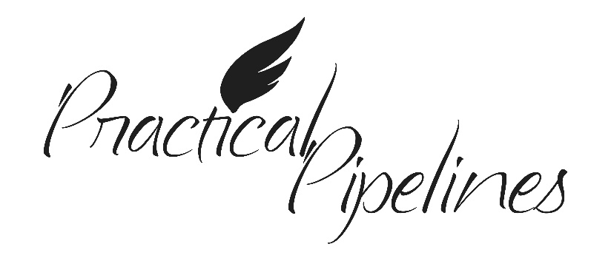

An overview including:
Pipelines Today, Pipeline Products, Pipeline Locations, Damage Prevention
Advance Preparedness and Emergency Response

Completed on ____________________, ________

Training Location: __________________________

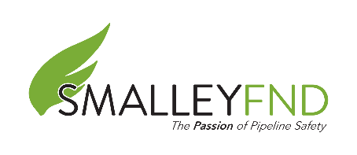

www.practicalpipelines.org Email: practicalpipelines@smalleyfnd.org Phone: 972.472.6500

